Tuning/modeling fast stages of ESB-MX

Tools
The tool used to record the bode plots is PBTuning.py, a script specially developed to record system responses.
The used frequencies are: 20 kHz Phase, 5 kHz Servo, 6.25MHz AdcAmp
This results in 50us PhaseTime and 0.2ms ServoTime.
According to the amplifier specs (Power Brick LV User Manual.pdf p.19). a DAC Value of 32737 ==2^15 corresponds to 33.85A current. So 1 curr_bit is 33.85/32737A =1.034mA.
The Parker stages are configured to contCur=800mA ,peakCur=2400mA. Ste Specs of the D11 stage are 0.8Amp RMS (producing 4N force) and 2.4Amp peak.
Measure Current Step
MXTuning.py –mode 1 → identifyFxFyStage.m

The current step looks similar for both motors.
The transfer function is: k*w0²/(w0²+2*damp*w0*s+s²)
rise time (0→100%) ca. 0.4ms
rise time: https://nptel.ac.in/courses/101108056/module7/lecture20.pdf
→ 1/(w0*np.sqrt(1-0.75**2))*(np.pi/2+np.arcsin(0.75)) )
The loop parameters are:
IiGain=5, IpfGain=8, IpbGain=8
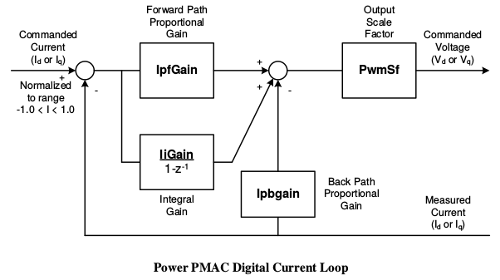

Measure Open Loop
The frequency response has been measured with sine and chirp with different amplitudes and frequency regions. The yellow line is averaged measurement data. The black line is the approximated model. The diagram shows curr_bits(ca.1mA) to ActPos (in um) transfer function. The images have been generated with MXTuning.py –mode 5 --dir MXTuning/18_10_02/.
Motor 1 (fy) open loop

Motor 2 (fx) open loop
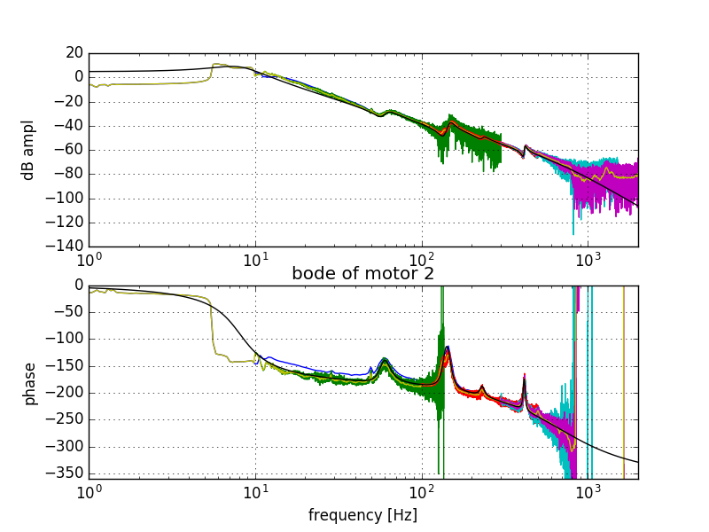
- motor 1 (fy) has a better response, as expected because it has less mass to move.

Motor 1 at : 0dB at 20.28Hz Motor 2 at : 0dB at 12.39Hz
10 Hz: 9.63 dB -134° 10 Hz: 4.68 dB -162°
100Hz: -28.5dB -191.7° 100 Hz: -38.15 dB -187.5°
resonances at:
198 Hz 60Hz,142Hz,414Hz,231Hz

→n times higher mass → n times lower frequency for same amplitude response
→n times higher frequency → n times higher velocity → n² times more acceleration==current
1um at 12Hz with 1 mA →with 2000mA → sqrt(2000)*12Hz=540Hz

A very simplified transfer function of the system is G(s)=k/s²

Closed Loop Tests

The pictures below are the shematics of the servo loop as printed in the DeltaTau manual.
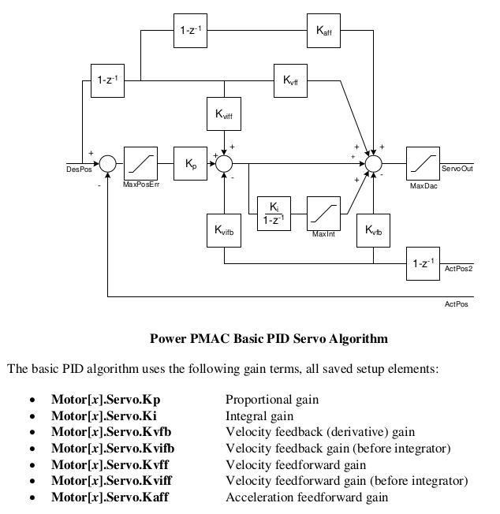
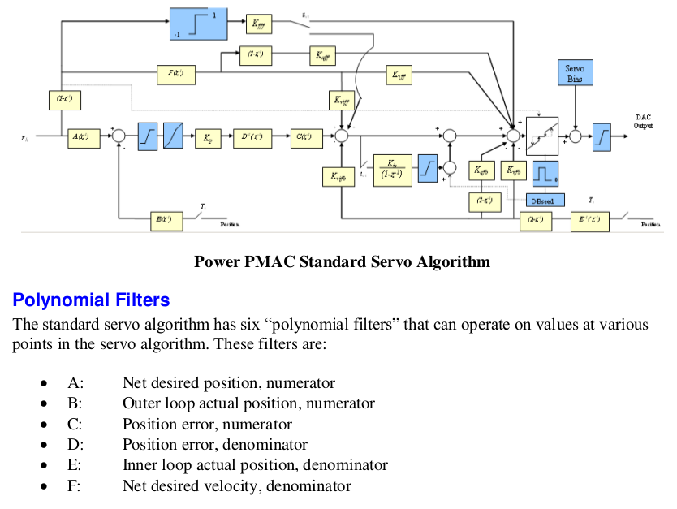
Following closed loops have been measured with the current control loop settings.
motor_servo(mot=1,Kp=25,Kvfb=400,Ki=0.02,Kvff=350,Kaff=5000,MaxInt=1000)
motor_servo(mot=2,Kp=22,Kvfb=350,Ki=0.02,Kvff=240,Kaff=1500,MaxInt=1000)

chirp sine closed loop
Bode plot and chirp input(blue) and output(green)

Motor 1 (fy) closed loop
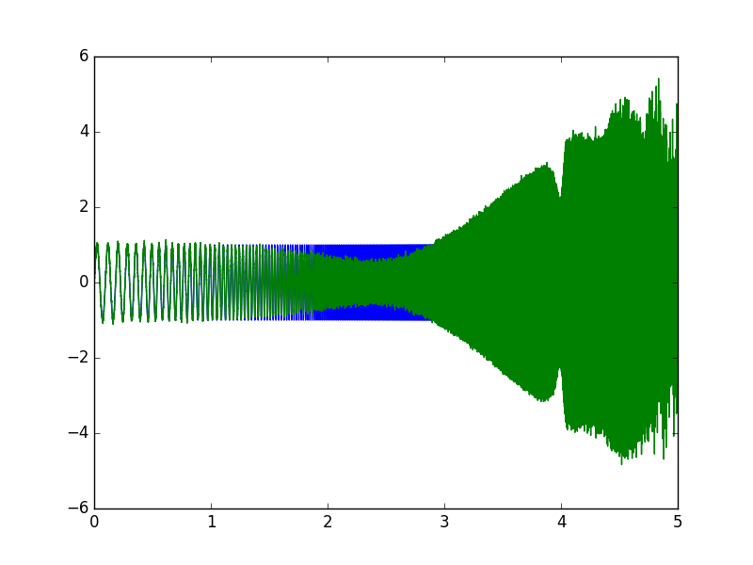
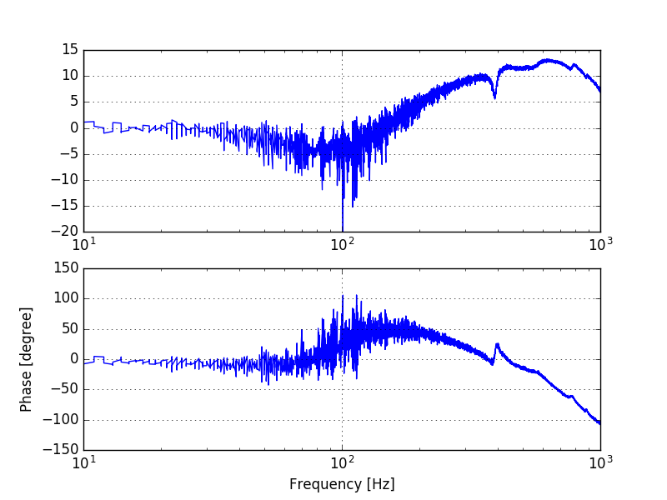
Moving 100um with frequencies from 1 to 100Hz
→ at frequencies above 150 Hz, the current increses up to 2 amps, and the the following error kicks in

Moving 1um with frequencies from 10 to 1000Hz
→The response becomes worse above 100Hz and overcompensates (ampl > 0dB)

Moving 1um at 1kHz seems to consume a current of about 2 amps.
Simulink simulation stage_closed_loop.slx with ServoDeltaTau_z G(z) showed similar response
Therefore the model seems good enough

Motor 2 (fx) closed loop

Moving 100um with frequencies from 1 to 100Hz-
→ similar to motor 1
Moving 1um with frequencies from 10 to 1000Hz
At frequency 270Hz the system is unstable. This could be due to the resonance frequency that is around there.
Moving 1um at 1kHz seems to consume a current of about 2 amps.
Simulink simulation stage_closed_loop.slx with ServoDeltaTau_z G(z) showed similar response
Therefore the model seems good enough

Conclusions:
-motors in closed loop becomes unstable or not well controlled at frequecies > 100Hz

chirp sine closed loop with simulink model
To compare the measurements with MATLAB model following lines were executed in MATLAB
clear;clear global;close all;
[mot1,mot2]=identifyFxFyStage();
[pb]=simFxFyStage(mot1);sim('stage_closed_loop');
close all;[ssc]=StateSpaceControlDesign(mot1);sim('observer');
[pb]=simFxFyStage(mot2);sim('stage_closed_loop');
close all;[ssc]=StateSpaceControlDesign(mot2);sim('observer');

Motor 1 sim Motor 2 sim
The simulated output corresponds well with the measured values above. Therefore the used model seem to be good to imrove the controller in MATLAB/simulink
The Simulink model ‘stage_closed_loop’ contains various controllers to check and compare the real measurements with the simulated model.
Improvement of the regulation with a simple PID loop and with prefilters did not improve the regulation quality. Therefore for better regulation quality more sophisticated controllers as state controllers will be tested.

State Space Controller with Observer
(s.a. http://ctms.engin.umich.edu/CTMS/index.php?example=Introduction&section=ControlStateSpace)
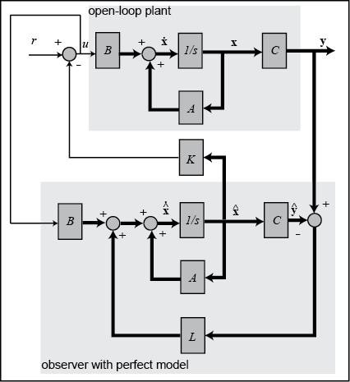
A standard PID controller uses feedback to detect errors between the desired position and the actual position and applies corrective commands to compensate for those errors. Although PID control is the most common type of industrial controller, it does have limitations.
The idea of a state space controller with observer is to have a model of the plant which follows all internal states of the real plant. All these internal states of the model can then be used states to build an optimal controller.
opposite to the PID cpntroller which is a ‘black-box design’, the state space controller with observer is a ‘white box design’

To implement a state space controller with observer the model has to be observable and controllable. The full model as used above is not controllable due to the various resonance frequencies. Therefore for the state space controller a simplified model without the resonance frequencies is used.
Following lines are used to build the state space controller
clear;clear global;close all;
[mot1,mot2]=identifyFxFyStage();
close all;[ssc]=StateSpaceControlDesign(mot1);sim('observer');
close all;[ssc]=StateSpaceControlDesign(mot2);sim('observer');
This plot displays bode diagrams of motor 2. The used model for the controller is the blue line, which contains the current loop model and the mechanical model.

The state space controller is calculated by pole placement on the observer model and on the closed loop system
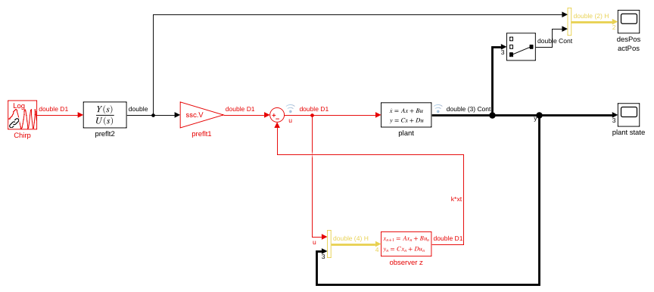
observer controller motor 1 observer controller motor 1
With an additional prefilter resonance and absorbsions can be suppressed a bit
observer with prefilter 1 observer with prefilter 2
Now the controller must be implemented on deltatau to check the performance on the real stage.

Implementing state space controller on Deltatau
In MATLAB the function StateSpaceControlDesign() MATLAB produces files /tmp/ssc[1|2].mat.
The driver code can be generated with: MXTuning.py –mode 8

Finally the real time servo code for the DeltaTau has to be compiled with:
/epics_ioc_modules/ESB_MX/python/usr_code$ make

The system was simulated with 5kHz servo loop frequency
Higher servo loop frequency does not help, because a continious state space controller behaves not relevantly better than a sampled state space controller at 5kHz.

Model of the stage instead of measuring transfer function

