Tuning/modeling fast stages of ESB-MX

Tools
The tool used to record the bode plots is PBTuning.py, a script specially developed to record system responses.
The used frequencies are: 20 kHz Phase, 5 kHz Servo, 6.25MHz AdcAmp
This results in 50us PhaseTime and 0.2ms ServoTime

Measure Current Step
MXTuning.py –mode 1 → identifyFxFyStage.m

The current step looks similar for both motors.
The transfer function is: k*w0²/(w0²+2*damp*w0*s+s²)
rise time (0→100%) ca. 0.4ms
rise time: https://nptel.ac.in/courses/101108056/module7/lecture20.pdf
→ 1/(w0*np.sqrt(1-0.75**2))*(np.pi/2+np.arcsin(0.75)) )
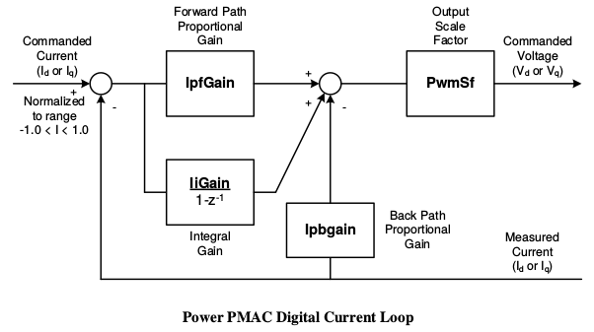
The loop parameters are:
IiGain=5, IpfGain=8, IpbGain=8

Measure Open Loop
The frequency response has been measured with sine and chirp with different amplitudes and frequency regions. The yellow line is averaged measurement data. The black line is the approximated model. The images have been generated with MXTuning.py –mode 5.

Motor 1 (fy) open loop

Motor 2 (fx) open loop
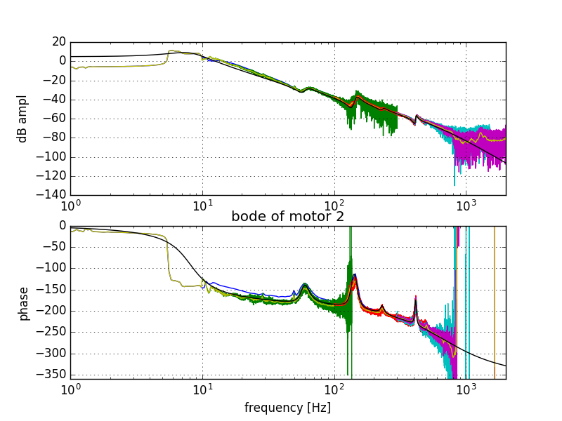
- motor 1 (fy) has a better response, as expected because it has less mass to move.
Motor 1 at : 0dB at 20.28 Motor 2 at : 0dB at 12.39Hz
10 Hz: 9.63 dB -134° 10 Hz: 4.68 dB -162°
100Hz: -28.5dB -191.7° 100 Hz: -38.15 dB -187.5°
TODO: check at low frequencies, if we loose position steps: move sine; #j=0; test position.

Closed Loop Tests
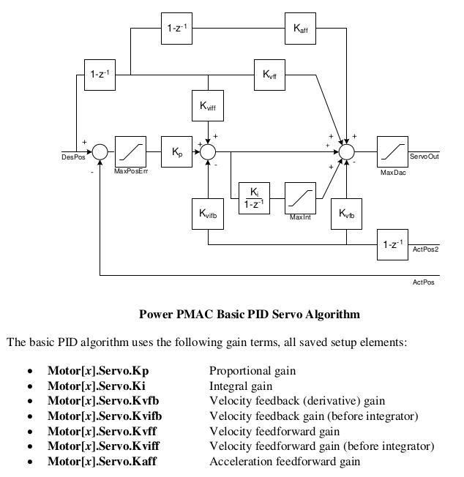
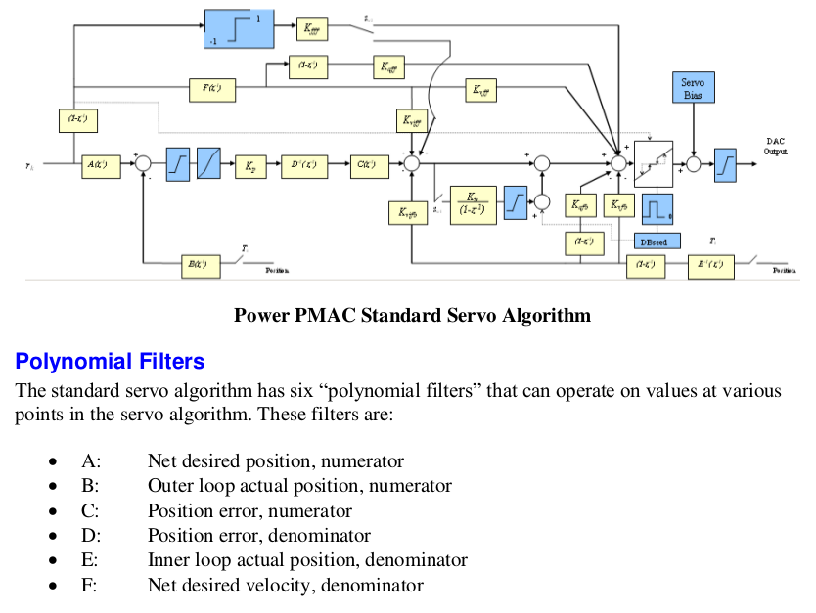

These Closed loops have been measured with the current control loop settings.
motor_servo(mot=1,,Kp=25,Kvfb=400,Ki=0.02,Kvff=350,Kaff=5000,MaxInt=1000)
motor_servo(mot=2,,Kp=22,Kvfb=350,Ki=0.02,Kvff=240,Kaff=1500,MaxInt=1000)

chirp sine closed loop
Bode plot and chirp input(blue) and output(green)

Motor 1 (fy) closed loop
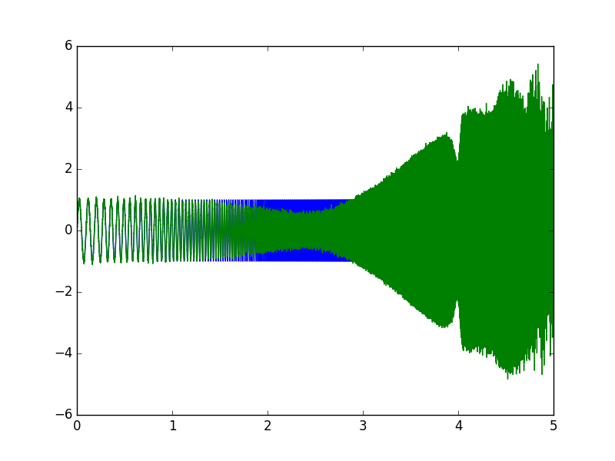
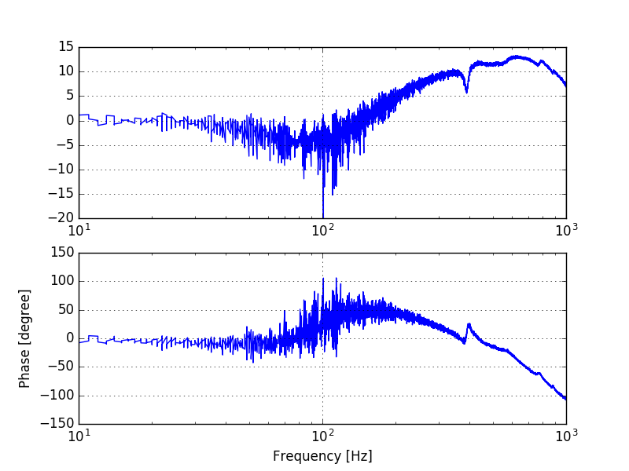

Moving 100um with frequencies from 1 to 100Hz-
→ at frequencies above 150 Hz, the current increses up to 2 amps, and the the following error kicks in

Moving 1um with frequencies from 10 to 1000Hz
The response becomes worse above 100Hz and overcompensates (ampl > 0dB)

Moving 1um at 1kHz seems to consume a current of about 2 amps.

Simulink simulation stage_closed_loop.slx with ServoDeltaTau_z G(z) showed similat response
Therefore the model seems good enough

Motor 2 (fx) closed loop

Moving 100um with frequencies from 1 to 100Hz-
→ similat to motor 1

Moving 1um with frequencies from 10 to 1000Hz
At frequency 270Hz the system is unstable. This could be due to the resonance frequency that is around there.

Moving 1um at 1kHz seems to consume a current of about 2 amps.

Simulink simulation stage_closed_loop.slx with ServoDeltaTau_z G(z) showed similar response
Therefore the model seems good enough

Conclusions:
-motors in closed loop becomes unstable or not well controlled at frequecies > 100Hz

Tests to do:
Step answer closed loop → time plot and fft spectrum.
Step size: 50um 100um 200um 500um 1000um

Sine at 100 Hz, Amplitude (peak to peak) 10um 20um 50um 100um

